Testing

For my tests, I had to make sure when a user pressed a button to answer a question, the correct response was correctly being put into a list. That list is used to find the recommended game. If the user wants to try again at the end, the list needs to be cleared first before selecting new answers. These screenshots show the list being printed after every answer selection. The list resets back to empty after hitting restart.

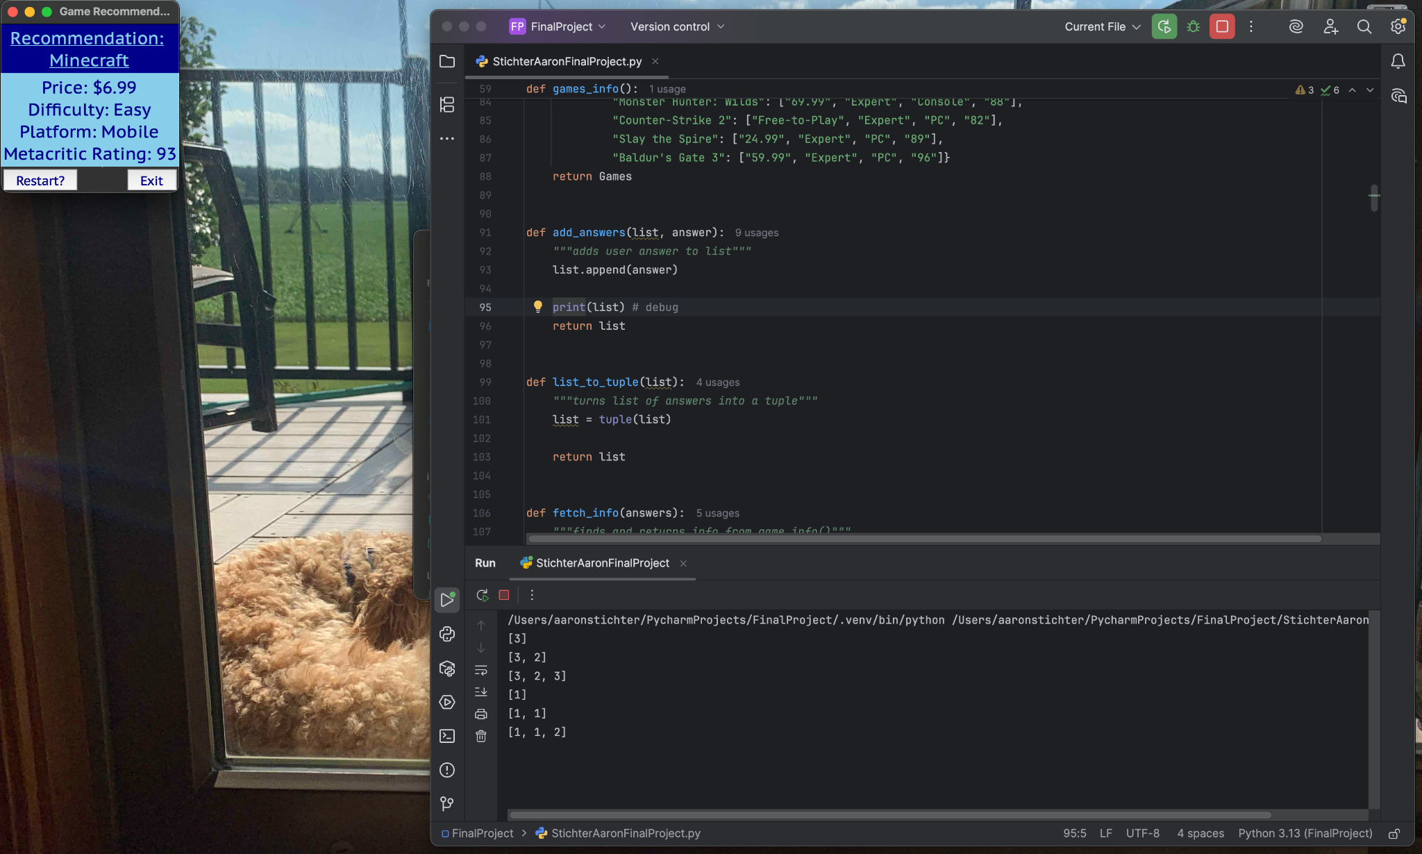

I also learned that I need to destroy elements when switching frames, otherwise they will still be in the same position underneath the new frame (or in the case of my labels, they will still be displayed along with the new labels in the new frame). To change this I had to add “button.destroy() and label.destroy()” in the command for every button, so the screen would be completely cleared for the next frame. Below, the first picture shows the buttons still being shown when the window is dragged open. The second picture shows no hidden buttons, as they have been destroyed.

